Variation in use of East Asian Late Paleolithic weapons: A study of tip cross-sectional area of stemmed points from Korea

Gayoung Park4,✉, Marlize Lombard5, Ben Marwick4, and Donghee Chong6

October 3, 2022

The introduction of blade technology, stemmed points, end scrapers, burins, denticulates, and finer grained materials led to the transition from the Early to Late Paleolithic in Korea. Stemmed points have been considered a representative tool that led this whole set of changes. In this research, we examine the function of stemmed points to understand the role that they played during the technological transition as well as throughout the Late Paleolithic. Our main questions are: What were stemmed points used for? How diverse were their functions? What are the temporal patterns in stemmed point functions? We measured tip cross-sectional areas (TCSA) to discriminate different functional classes of projectile points, for example, poisoned arrowheads or thrusting spear. We analyze TCSA with other variables including raw materials, weight, site and radiocarbon dates. Our results show that the stemmed points mostly functioned as javelins and thrusting spear tips, with smaller numbers as dart tips and arrowheads. TCSA values are depending on size and raw material types. We found different usage of stemmed points in different sites, which could indicate people used stemmed points in different ways depending on the environment. However, some sites show a wide range of TCSA values that represent multi-purpose usage of stemmed points. The temporal pattern of TCSA values is one of little change throughout the Late Paleolithic period. We conclude that stemmed points were mainly used as Javelin but they were multi-functional tools.

1 Department of Anthropology, University of Washington  
2 Palaeo-Research Institute, University of Johannesburg  
3 Department of History, Kyung Hee University  
4 uw  
5 uj  
6 uk

✉ Correspondence: [Gayoung Park <gayoungp@uw.edu>](mailto:gayoungp@uw.edu)

# Introduction

With the introduction of new technologies, the Korean Paleolithic transitioned from the Early to the Late Paleolithic periods. The transition includes blade technology, stemmed points, end scrapers, burins, denticulates, etc (Bae et al., 2017; Bae, 2017; Lee et al., 2017; Nakazawa and Bae, 2018; Seong and Bae, 2016). Another notable change is the selective use of raw materials along with the emergence of new tools. Previously quartzite and vein quartz were the most commonly used for core and flake tools but finer grained materials such as silicified tuff (shale), chert, hornfels, and obsidian became more important to the lithic technology during the Late Paleolithic. While people still used coarse materials with existing tools, they selectively chose finer materials for newly introduced tools. (Seong, 2004, 2003). Stemmed points are considered the first evidence of the new technology, as well as the Late Paleolithic, since they led to the whole set of changes (Seong, 2008; Seong and Bae, 2016). This is related to the fact that stemmed points originate from Korea in Northeast Asia and have a close association with mobility, site formation, and occupation diversity (Chong, 2021; O’Driscoll and Thompson, 2018; Park and Marwick, 2022). Despite the importance of stemmed points, only a few studies have examined their use, whereas researchers often discuss stemmed points relating to their origin and chronology of the Korean Late Paleolithic and their relationship with Japan (Chang, 2013; Chong, 2021; Lee and Sano, 2019; Park, 2013).(Chang, 2013; Chong, 2021; Lee and Sano, 2019; Park, 2013).

To understand the role stemmed points played in the technological transition, this study examines the functions of stemmed points. We use the tip cross-sectional area (TCSA) metric to calculate artifact function and compare the results to other archaeological and ethnographic assemblages based on the idea that different shapes correspond to different functions (Lombard, 2021). We then explore the relationship between and function raw materials, artifact size and discard location, and how these change over time. Our main questions are: What were stemmed points used for? How diverse were their functions? What are the temporal patterns in stemmed point functions? As part of our discussion, we examine possible connections between the roles of stemmed points and population dynamics or environmental change during the Late Paleolithic period. In order to understand how a certain weapon-tip type was chosen, we purposely borrow evolutionary perspective and premise that human groups had the cognitive capacity to choose proper weapons depending on their hunting strategies and socio-environmental circumstances.

## Why Stemmed Points?

Stemmed points (Sumbejjirugae) are projectile points made on an elongated blade-like flake or blade with two parallel facets and a single or two arises that converge to form an inverted “Y” (Pratt et al., 2020) (**?@fig-sp-hand-made**). Slight retouch is located on the proximal end to shape an acute tip and on the distal end to make a stem, which connects to a wooden shaft. These types of artifacts are often called tanged points, but we prefer ‘stemmed point’ here to distinguish from Bronze Age stone projectile points that have long been called ‘tanged points’ in Korea (Park and Marwick, 2022). After the first discovery at the Suyanggae site, more than 450 stemmed points have been found in over 30 sites (Chong, 2021). The emergence of stemmed points is relevant to questions about the origins of projectile technology, the emergence of the Late Paleoltihic, and relationships to adjacent regions in East Asia, such as Japan.

The stemmed point is the first composite tool in the Korean Paleolithic that requires two different parts, consisting of a stone point and shaft, presumably made out of wood (Seong, 2008). Using blades enables mass production for this composite tool and its shape becomes more standardized (Lee, 2015; Park and Marwick, 2022). Therefore, -O’Driscoll and Thompson (2018) claims that understanding the emergence of projectile technology gives insights to greater cultural, evolutionary, and behavioral cognitive flexibility.

Since the stemmed points represent the beginning of the Korean Late Paleolithic, investigating their origin(s) becomes a key for understanding the technological transition from the Early Paleoltihic, modern human dispersals, and existence of the ‘Middle’ Paleolithic in Korea (Bae, 2017; Bae, 2010; Norton and Jin, 2009; Seong and Bae, 2016). There has been a northworthy debate about explaining the origin(s) of stemmed points and it can be summarized into two competing models: ‘heterogenic’ migration (Bae, 2010), in situ evolution(Seong, 2009). The migration model claims that the new blade industry including stemmed points, and the earlier coarse flake tradition including large cores, polyhedrons, choppers, and even handaxes, came from different origins (e.g. 1: North route: Siberia, Mongolia, or other regions of northeast China, and 2: South route: southern China) as the result of continuing influx of modern human migration from two routes. The ‘in situ’ model argues that stemmed points and other Late Paleolithic technologies, including blade industries, autonomously emerged in the south of the Korean peninsula, with no apparent external influence. The difference between the two models comes from how to understand a few early sites that contain stemmed points but no blades and blade coares. The ‘in situ’ model claims that the stemmed points appeared before blades by acknowledging those early sites including Bonggok, Songamri, Yonghodong, and Hwadaeri sites while migration model supports the traditional definition of the Late or Upper Palaeolithic in Europe and Africa that started with emergence and establishment of blade technology (Seong and Bae, 2016).

Stemmed points are important proxies to understand human behaviors during the Late Paleolithic. -Park and Marwick (2022) examine mobility and site occupation patterns through lithic assemblages and concepts of human behavioral ecology and find that forager groups using stemmed points may have been associated with occupation of marginal or extreme environments compared to the groups with no stemmed points. Also, they were more associated with expedient technologies, indicating residential and less mobile behaviors. -Chong (2021) claims that the morphological variation of the stemmed points along with tool types in lithic assemblages, assemblage size, use of raw materials, and types of blanks could represent the characteristics of occupations such as “limited activity station” and “residential base camp.” For example, stemmed points with high morphological variations in a tool size, shape of edge, degrees of damage, and types of edge retouching from Yongsandong site indicate that the site was used for specific or limited activities such as hunting (Chong, 2021; Kim, 2004; Seong, 2015).

The presence of stemmed points in both Korean and Japan has been studied since the late 1980s as a part of evidence for long-distance/maritime cultural interchanges or social networks (Lee, 2015). Stemmed points from the Bonggok site in Korea are currently accepted as the oldest ones among Northeast Asia, dated to ca. 41.5 ka, and made on elongated flakes (Bae et al., 2017; Seong, 2015, 2009). After their first appearance in Korea, stemmed points (Hakuhensenntouki in Japanese) appear in Kyushu, Japan during late MIS 3. In addition to the stemmed points, there are similar artifacts found in both regions such as microblade cores, Moppule-seokgi (Kakusuijyosekki in Japanese), backed knife, bilateral points, bifacial points, and transport of obsidian (Chang, 2013; Kim and Chang, 2021; Lee, 2015, 2012). In addition, stemmed points also help understand the connections and technological transitions between islands in Japan (Chang, 2013).

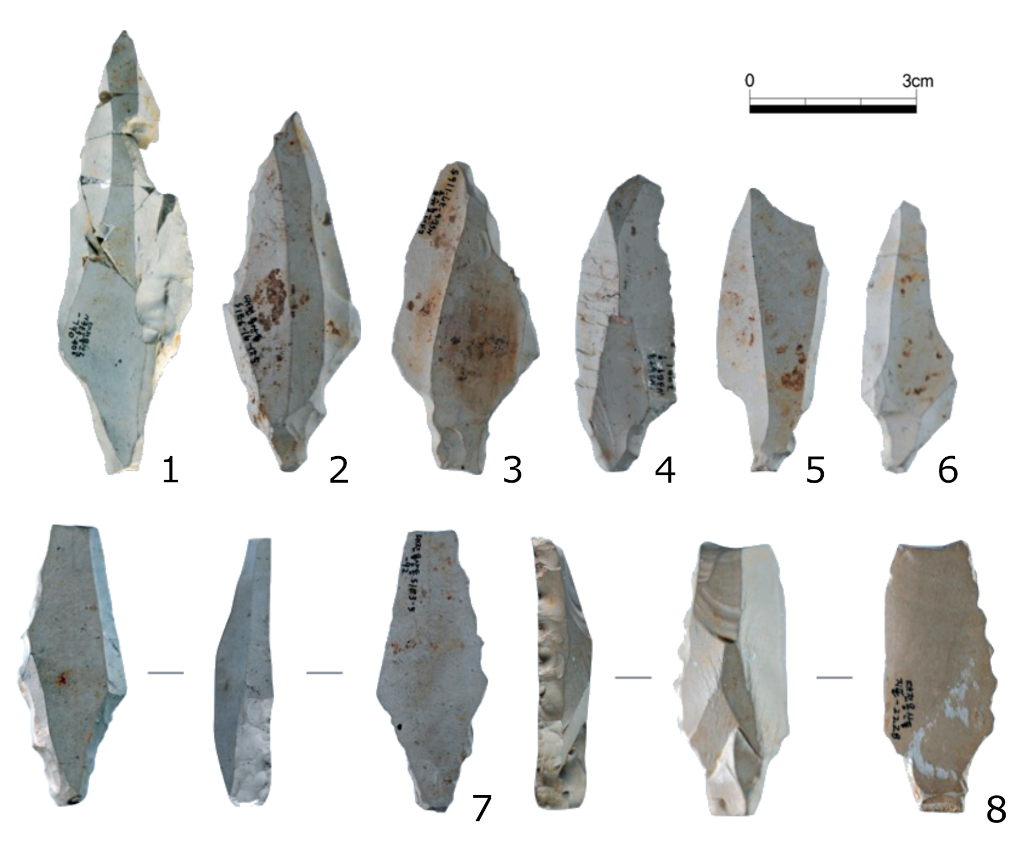

## Previous studies about the stemmed points function

Though the stemmed points are generally assumed as hunting armatures (Chang, 2013; Lee and Sano, 2019; Lee and Jang, 2011a; Lee and Kong, 2002a; Seong, 2008), it is difficult to understand the function of the tools without knowing their complete shape attached to other components. Preserved wooden components of projectile tools are too few and rare to generalize the overall scale and variability of the tools used in prehistory (Shea, 2006). -Lee and Kong (2002b) claimed to name the stemmed points as ‘stemmed tools’ because of the diverse shape of stemmed points, which could represent different functions as well as the uncertainty of complete tool shape. Other researchers agree that some stemmed points that are not symmetrical and have retouch on one side of the artifacts or have denticulate blades on one side should not be called as stemmed points but stemmed knives, stemmed side-scrapers, stemmed end-scrapers, or stemmed burins (Kim, n.d.; Lee and Jang, 2011b; Seong, 2008) (**?@fig-sp-hand-made**: 7-8).

Most stemmed points are symmetrical from the tip to the tang, having the central axis function as a line of symmetry (Lee and Jang, 2011b). The studies of the stemmed points manufacturing process and the patterns of broken pieces show that stemmed points might be used mainly as spear tips (Chang, 2002; Lee, 1985). There are a high proportion of broken tips and stems and the reused tools were repaired based on keeping the symmetry (Kim, n.d.; Park, 2013). In addition to the morphological aspect of stemmed points, investigating the whole site and tool composition of an assemblage show that stemmed points or stemmed tools are strongly associated with hunting activities including peeling the animal skin after slaughtering or separating the bones from the flesh (Chong, 2021; Seong, 2008).

A recent study conducts use-wear analysis on 95 stemmed points from the Jingeuneul site along with fracture patterns, TCSA, tip cross-sectional perimeter (TCSP), and neck width to understand the use of the tools (Lee and Sano, 2019). Their results show that a considerable number of the stemmed points show diagnostic impact fractures (DIFs) on the surface, which could occur due to longitudinal force from the shaft when a stone tip hits a target. In other words, their research indicates that stemmed points could be used as spear-throwers or bows (Sano and Oba, 2015).

## Tip Cross-Sectional Area

The tip cross-sectional area (TCSA) has been used as a ballistically significant standard to discriminate different functional classes of projectile armatures such as spearthrower (a.k.a. atlatl) dart tips, arrowheads and large experimental stabbing/thrusting spears (Lombard, 2021, 2020; Lombard and Shea, 2021; O’Driscoll and Thompson, 2018; Sisk and Shea, 2011). TCSA metric indicates the part of the tool that cuts the target’s hide and relates to weapon flight and penetration dynamics (Hughes, 1998; Lombard, 2021; Sitton et al., 2020). This method was first proposed by -Hughes (1998) and and tested by -Shea (2006) through comparing archeological examples to ethnographically collected samples of known use. -Shea (2009) also applied this approach to compare projectile points from Africa, the Levant, and Europe and claimed that projectile weapons first appeared in Africa. The main advantage of the TCSA is, regardless of point type, only maximum width and thickness measurements are needed for calculating the TCSA value (0.5 × maximum width × maximum thickness) (Lombard, 2020; Sisk and Shea, 2011). Later, -Sisk and Shea (2011) proposed an alternate measure, tip cross-sectional perimeter (TCSP), for more accurate measure for the force needed to penetrate a target to a lethal depth while TCSA metric is more associated with cutting aspect. However, TCSP has a few disadvantages to directly apply to our case of stemmed points. The force and penetration depth are not only affected by the stone tip but also by the mass of the shaft, which cannot be known for archaeological stone-tipped weapons (Lombard, 2020). -(**sisk2011?**) also mentioned that TCSP cannot be applied to backed pieces that are hafted as projectile armatures.

-Lee and Sano (2019) first applied TCSA to stemmed points from Korea along with their use-wear analysis. The stemmed points for their research were discovered from Jingeuneul site located in southwest of Korea, where the largest number of stemmed points (n = 99) were found in a single site. For TCSA, they were only able to use ten stemmed points because they needed to select the stemmed points that retained the widest and thickest part of the specimens for TCSA metric and displayed diagnostic impact fractures for the use-wear analysis. The purpose of using TCSA in their research is to compare the values to North American dart tips and arrowheads. Their results show that the TCSA range of Jingeuneul stemmed points is relatively wide overlapped with both North American dart tips and arrowheads. Inspired by -Lee and Sano (2019) in addition to other prior research that developed and applied TCSA into archaeological materials from other parts of the world, we explore stemmed points from all over South Korea to better understand their function to understand the role that stemmed points represent during the Late Paleolithic.

# Methods

## Archaeological sites

After the first evidence of the Korean Late Paleolithic discovered at Seokjangri site including blade and a stemmed base, around 300 stemmed points have been found in Korea (Lee and Sano, 2019; Sohn, 1967). Most sites contain only a few stemmed points and only a few sites have many more, such as Jingeuneul, Suyanggae (n = 55), and Yongsandong (n = 38) (Kim, 2017). Among these stemmed points, we gathered those that retained the widest and thickest part of specimens. Our dataset contains stemmed points that were found during field surveys as well as those were from sites that were never dated but accompanied with other Late Paleoltihic artifacts. Those criteria resulted in a sample of 173 stemmed points from 36 assemblages unearthed from 29 sites spanning the period 44-10 ka (Figure 2). The dimensions of the 173 stemmed points were obtained from published excavation reports and by direct measurements during our visits to the collections of Korean local museums and archaeological institutions.

We distinguished multiple assemblages in one site where numerous excavations have been conducted in different spots and by different institutions under the same site name. For example, Suyanggae site, one of the Korean National Heritage sites, has been excavated more than ten times since 1980 by the local university museum and later by archaeology research institutions. There are six different excavation spots apart from each other from a few meters to a few kilometers. The archaeologists identified multiple assemblages in each excavation or even a trench by culturally sterile deposits, or where distinct artifact-bearing stratigraphic units could be identified by major differences in the texture, color, and composition of the sedimentary deposits. In this research, we used four assemblages from the Suyanggae site and we separated one assemblage among the four by using a different site name, Hajinri. Because Hajinri was from the sixth excavation area, which is 3.5 kilometers apart from the other spots and dated to much earlier (around 42-30 ka) than the other assemblages (around 31-15 ka). According to the excavation reports for Hajinri, stemmed points first appeared in Hajinri around 42 ka with the earliest blade and blade cores (Lee et al., 2018). We consider this assemblage as an unusual outlier because the stemmed points and blades from Hajinri are highly standardized and refined, which are only found at other sites much later in time. We consider Bonggok site, which has the second-earliest dates (41.5 ka) in our collection, is the actual earliest site. Bonggok site includes blades or elongate flakes but it is hard to define without accompanying blade core (Park and Marwick, 2022).

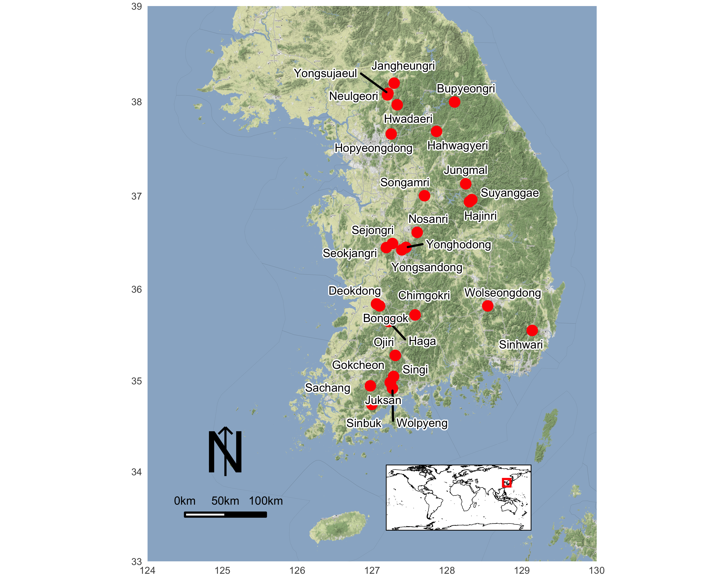

## Applying TCSA

To answer our research questions, What were stemmed points used for? How diverse were their functions? What are the temporal patterns in stemmed point functions? Are these temporal patterns associated with population dynamics or environmental processes? We calculated TCSA values for stemmed points and explored the usage for the stemmed points depending on raw materials, location, and size. We applied radiocarbon dates to the results to examine the temporal patterns. In the discussion, we compared those temporal patterns with demographic and environmental proxies. We used the results of summed probability distributions (SPD) and annual temperature changes from -Park and Marwick (2022) which covers our target period and area. Following the TCSA ranges for different weapon-delivery systems that -Lombard (2021) created by summarizing -Wadley and Mohapi (2008)’ study of backed microliths (Table 1?), we excluded 12 artifacts from our dataset. Because the TCSA values of those 12 artifacts from Bupyeongri, Hwadaeri, Haga, Sinhwari, Gokcheon, and Sachang sites are greater than 257. Their TCSA range is from 263 to 2622. Therefore, a total of 161 stemmed points from 32 assemblages unearthed from 26 sites are used for the following analysis.

TCSA range from Lombard (2021)

| Weapon type | N of tools | Mean TCSA | SD | TCSA Range |
| --- | --- | --- | --- | --- |
| Poisoned arrowheads | 434 | 11 | 7 | 4-18 |
| Arroheads | 118 | 33 | 20 | 13-53 |
| Dart tips | 40 | 58 | 18 | 40-76 |
| All javelins of known use | 137 | 71 | 27 | 44-98 |
| Thrusting spear tips | 75 | 159 | 71 | 88-230 |

### Raw materials

Selective use of raw material is one of the main technological transitions to the Korea Late Paleolithic. Previously used quartzite and vein quartz were continuously selected for the existing core and flake tools and finer grained materials were newly added to assemblages for producing the newly introduced tools (Seong, 2004). We analyze TCSA values per each raw material and examine why types of raw materials were selected for certain types of tool.

### Regional Pattern

We present TCSA values per site that contains more than 4 stemmed points (more than and equal to 5?) based on the evolutionary concept that people choose their tools according to the surrounding environment and available resources. Through the TCSA distribution, we explore which function(s) the stemmed points had performed at the sites.

### Weight

Different sizes of stone artifacts can represent different functions. Overall size of stone points has been used as a potential proxy to separate different armature types (Sahle and Brooks, 2019; Thomas, 1978). We chose weight as a size indicator for the stemmed points. The weight is a reliable discriminator between tools and a descriptive attribute which can be determined objectively and which serves as a criterion of likeness or dissimilarity in projectile point description (Fenenga, 1953; Shea, 2006). Excluding 9 points that we were not able to measure or get the records of weight, we calculate TCSA for 152 artifacts.

### Temporal pattern

We add radiocarbon dates to explore the temporal pattern of the function of stemmed points. We excluded the assemblages that have no radiocarbon dates. We arrange 24 assemblages dated from 45ka to 14.8ka periodically, and compute TCSA.

## Choice of weapon-tip types

The introduction of new types reflect major implications for social transformation. For example, the bow and arrow enabled individuals to work without hunting teams and provided opportunities for non-elite hunters to produce their own subsistence or pursue individual wealth (Angelbeck and Cameron, 2014; Bettinger, 2013; Rorabaugh and Fulkerson, 2015). In evolutionary terms, we assume that human groups carefully selected a specific stone tool based on its functional advantage over other alternatives once they acquired the necessary physiological and cognitive abilities to innovate (Lombard et al., 2022). The choice of weapon-tip types, therefore, reflects the socio-environmental circumstances that they had to encounter and overcome. -Eren et al. (2022) claim that Clovis points were more variable in shape than Folsom points because Clovis foragers were exposed to largely unfamiliar landscape and employed their points as multifunctional tools that perform a wider range of tasks including cutting and sawing. Folsom points show a narrow range of variation, indicating a specific task. They used TCSA to assess the morphological variance of the points as well as understand the potential functional costs or benefits of one artifact variant relative to another.

Similar to -Eren et al. (2022)’s approach, we hypothesize two scenarios that explain the regional or/and temporal pattern of TCSA range. If stemmed points represent a narrow TCSA range, people produced tools that performed certain tasks. There could be less surprise in the surrounding environment. On the other hand, a wide TCSA range indicates that stemmed points could be multifunctional tools and people might need to be prepared for unexpected situations such as moving into an unfamiliar landscape or their patch becoming less productive. We expect to observe various TCSA ranges, which reflect morphologically and functionally different stemmed points, across different regions or environments. However, we acknowledge that lithic morphology is highly dependent on the quality of raw materials and their availability.

The entire R code (Core, 2021) and data files used for all the analysis and visualizations contained in this paper is openly available at https://doi-org/xxxx to enable re-use of materials and improve reproducibility and transparency (Marwick, 2017). All of the figures, tables, statistical test results presented here in addition to the raw data can be independently reproduced with the code and data in this repository. The code is released under the MIT license, the data as CC-0, and figures as CC-BY, to enable maximum re-use.

# Results

## TCSA range of Korean stemmed points

|  |
| --- |
| Figure 1: Distribution of TCSA values for all Korean stemmed points in the current dataset. Shaded boxes show TSCA ranges for various weapon types. |

To gain a general idea of the role of stemmed points, we calculated TCSA for all stemmed points. Figure 1 shows the mean TCSA is 95.5, and standard deviation of TCSA is 44.1. Overall we see a wide variation of TCSA values in this boxplot. According to -Lombard (2021) TCSA ranges (Table 1), Korean stemmed points are mostly in the categories of javelins and thrusting spear tips, with smaller numbers as dart tips and arrowheads. Among the weapon-tip types, only poison arrowheads appear to be absent from these Korean assemblages.

## Variation by raw material

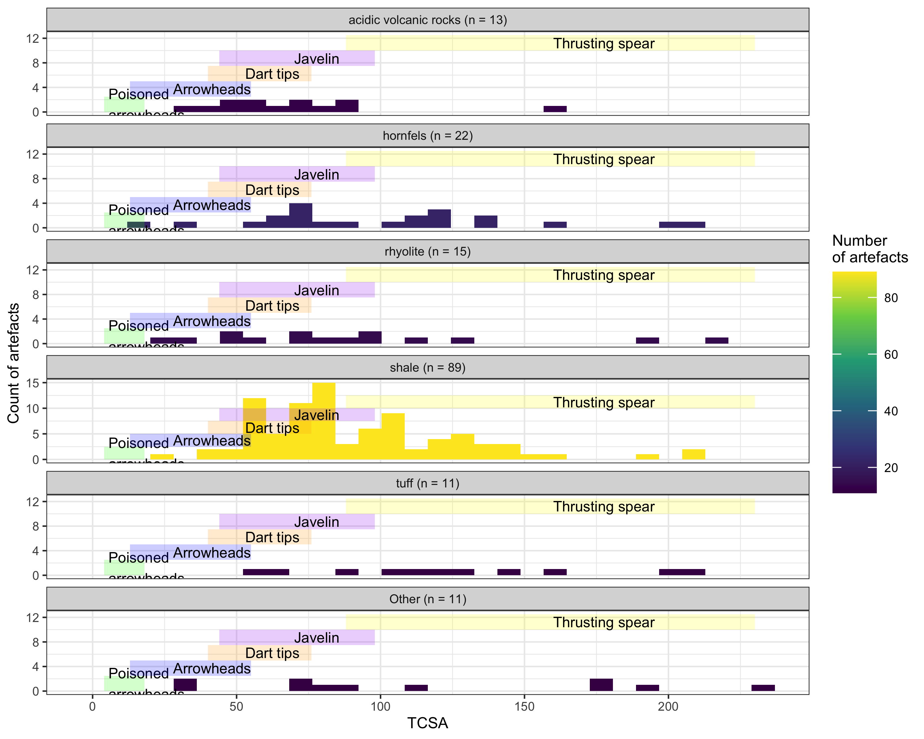

1. About half of all the stemmed points made out of shale (**?@fig-tcsa-raw-materials**).
2. Acidic volcanic rocks tend to have skewed lower TCSA values.
3. But overall, there is no clear pattern of different TCSA values by raw material.

## Variation by site (Regional pattern)

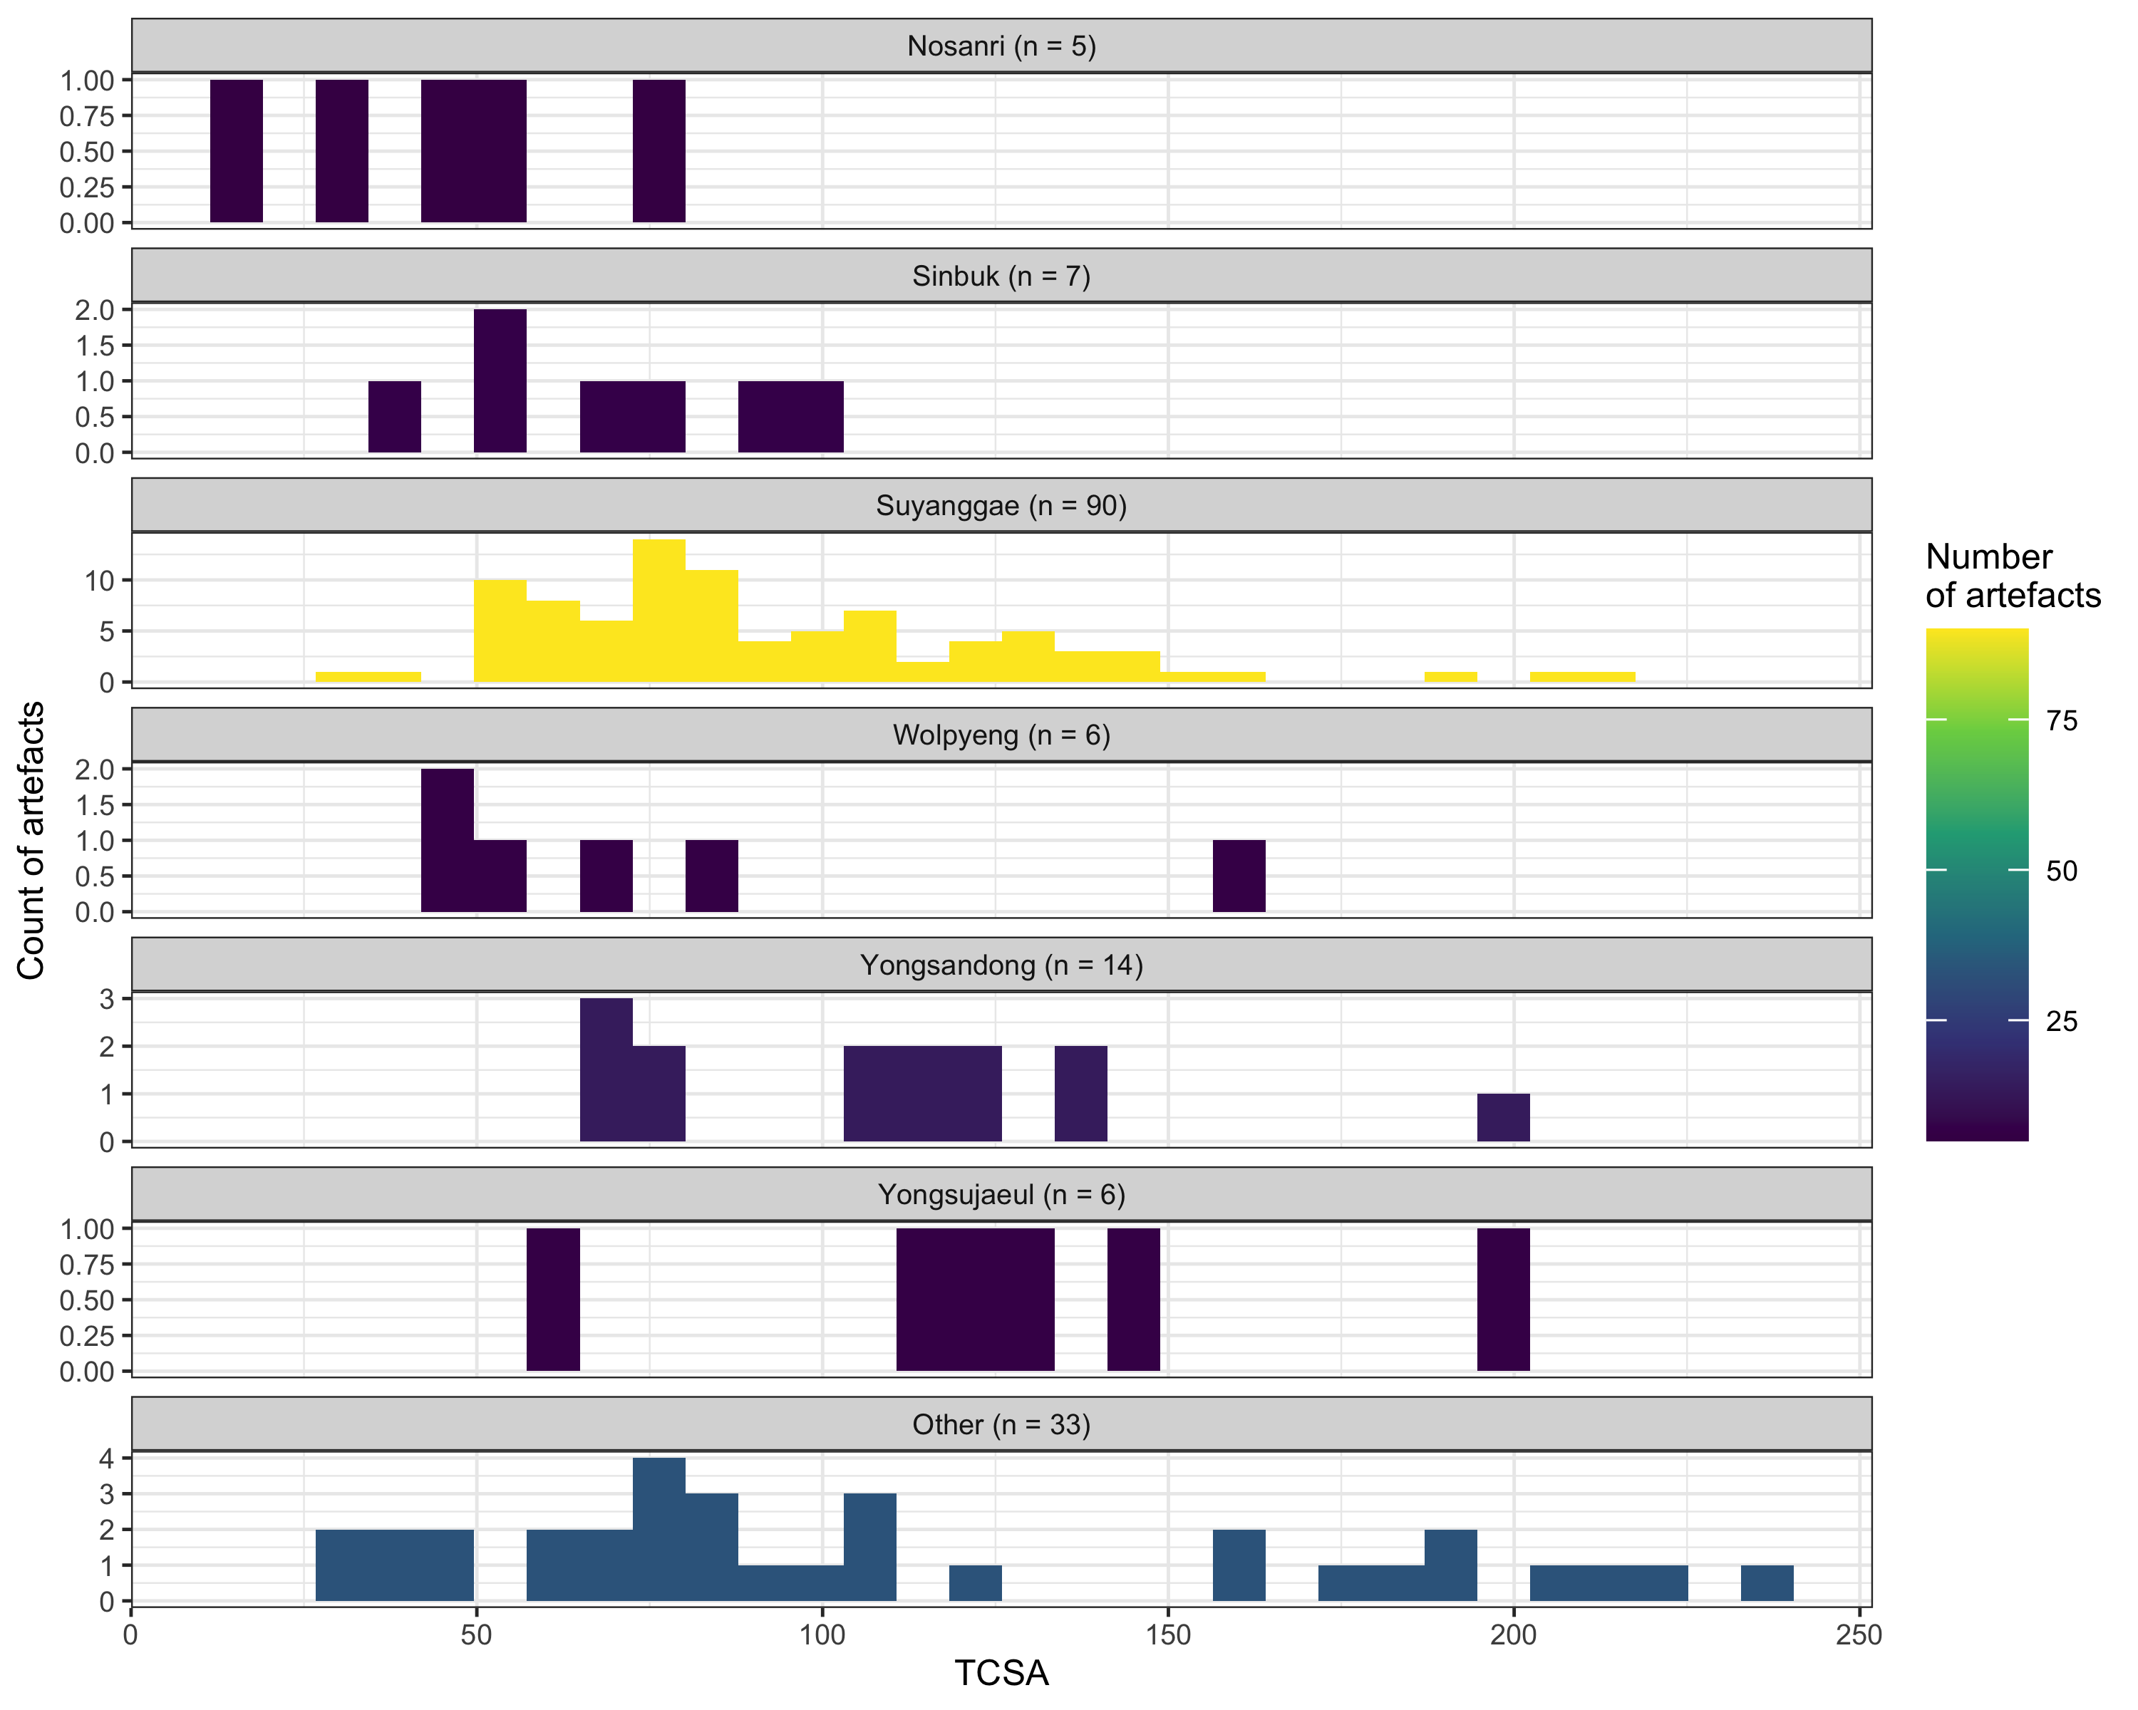

1. We computed TCSA for sites that include >= 5 stemmed points.
2. Suyanggage has the most stemmed points and the range of TCSA is wide. We can assume that people used stemmed points for a variety of different purposes.
3. Nosanri and Sibuk have similarly small TCSA values, perhaps these sites had similar functions? Wolpyeng and Yongsujaeul have similar amounts of stemmed points to Nosanri and Sibuk, but different distribution of TCSA values, so perhaps Wolpyeng and Yongsujaeul had a different role in the foragers’ land use system compared to Nosanri and Sibuk.

## Variation by size (weight)

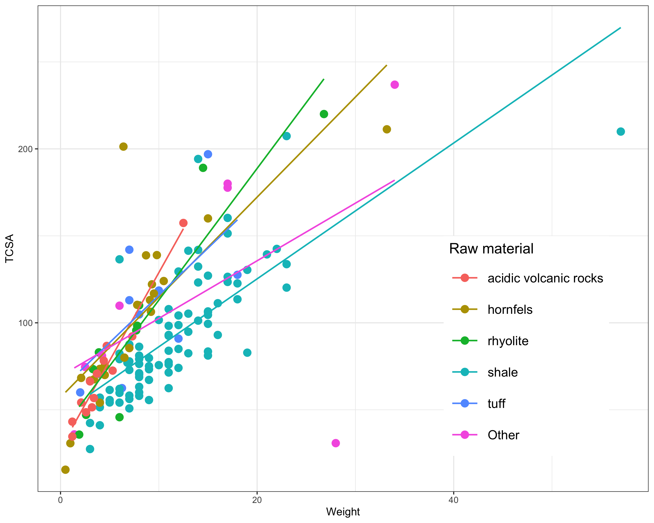

1. TCSA and artefact weight have a positive relationship.
2. The relationship between TCSA and artefact weight varies by raw material, perhaps due to variation in the density of different lithic raw materials
3. Shale stemmed points tend to have TCSA values that are strongly correlated with artefact size, while acidic volcanic points have TCSA values that vary over a very limited size range, suggesting size is less influential.

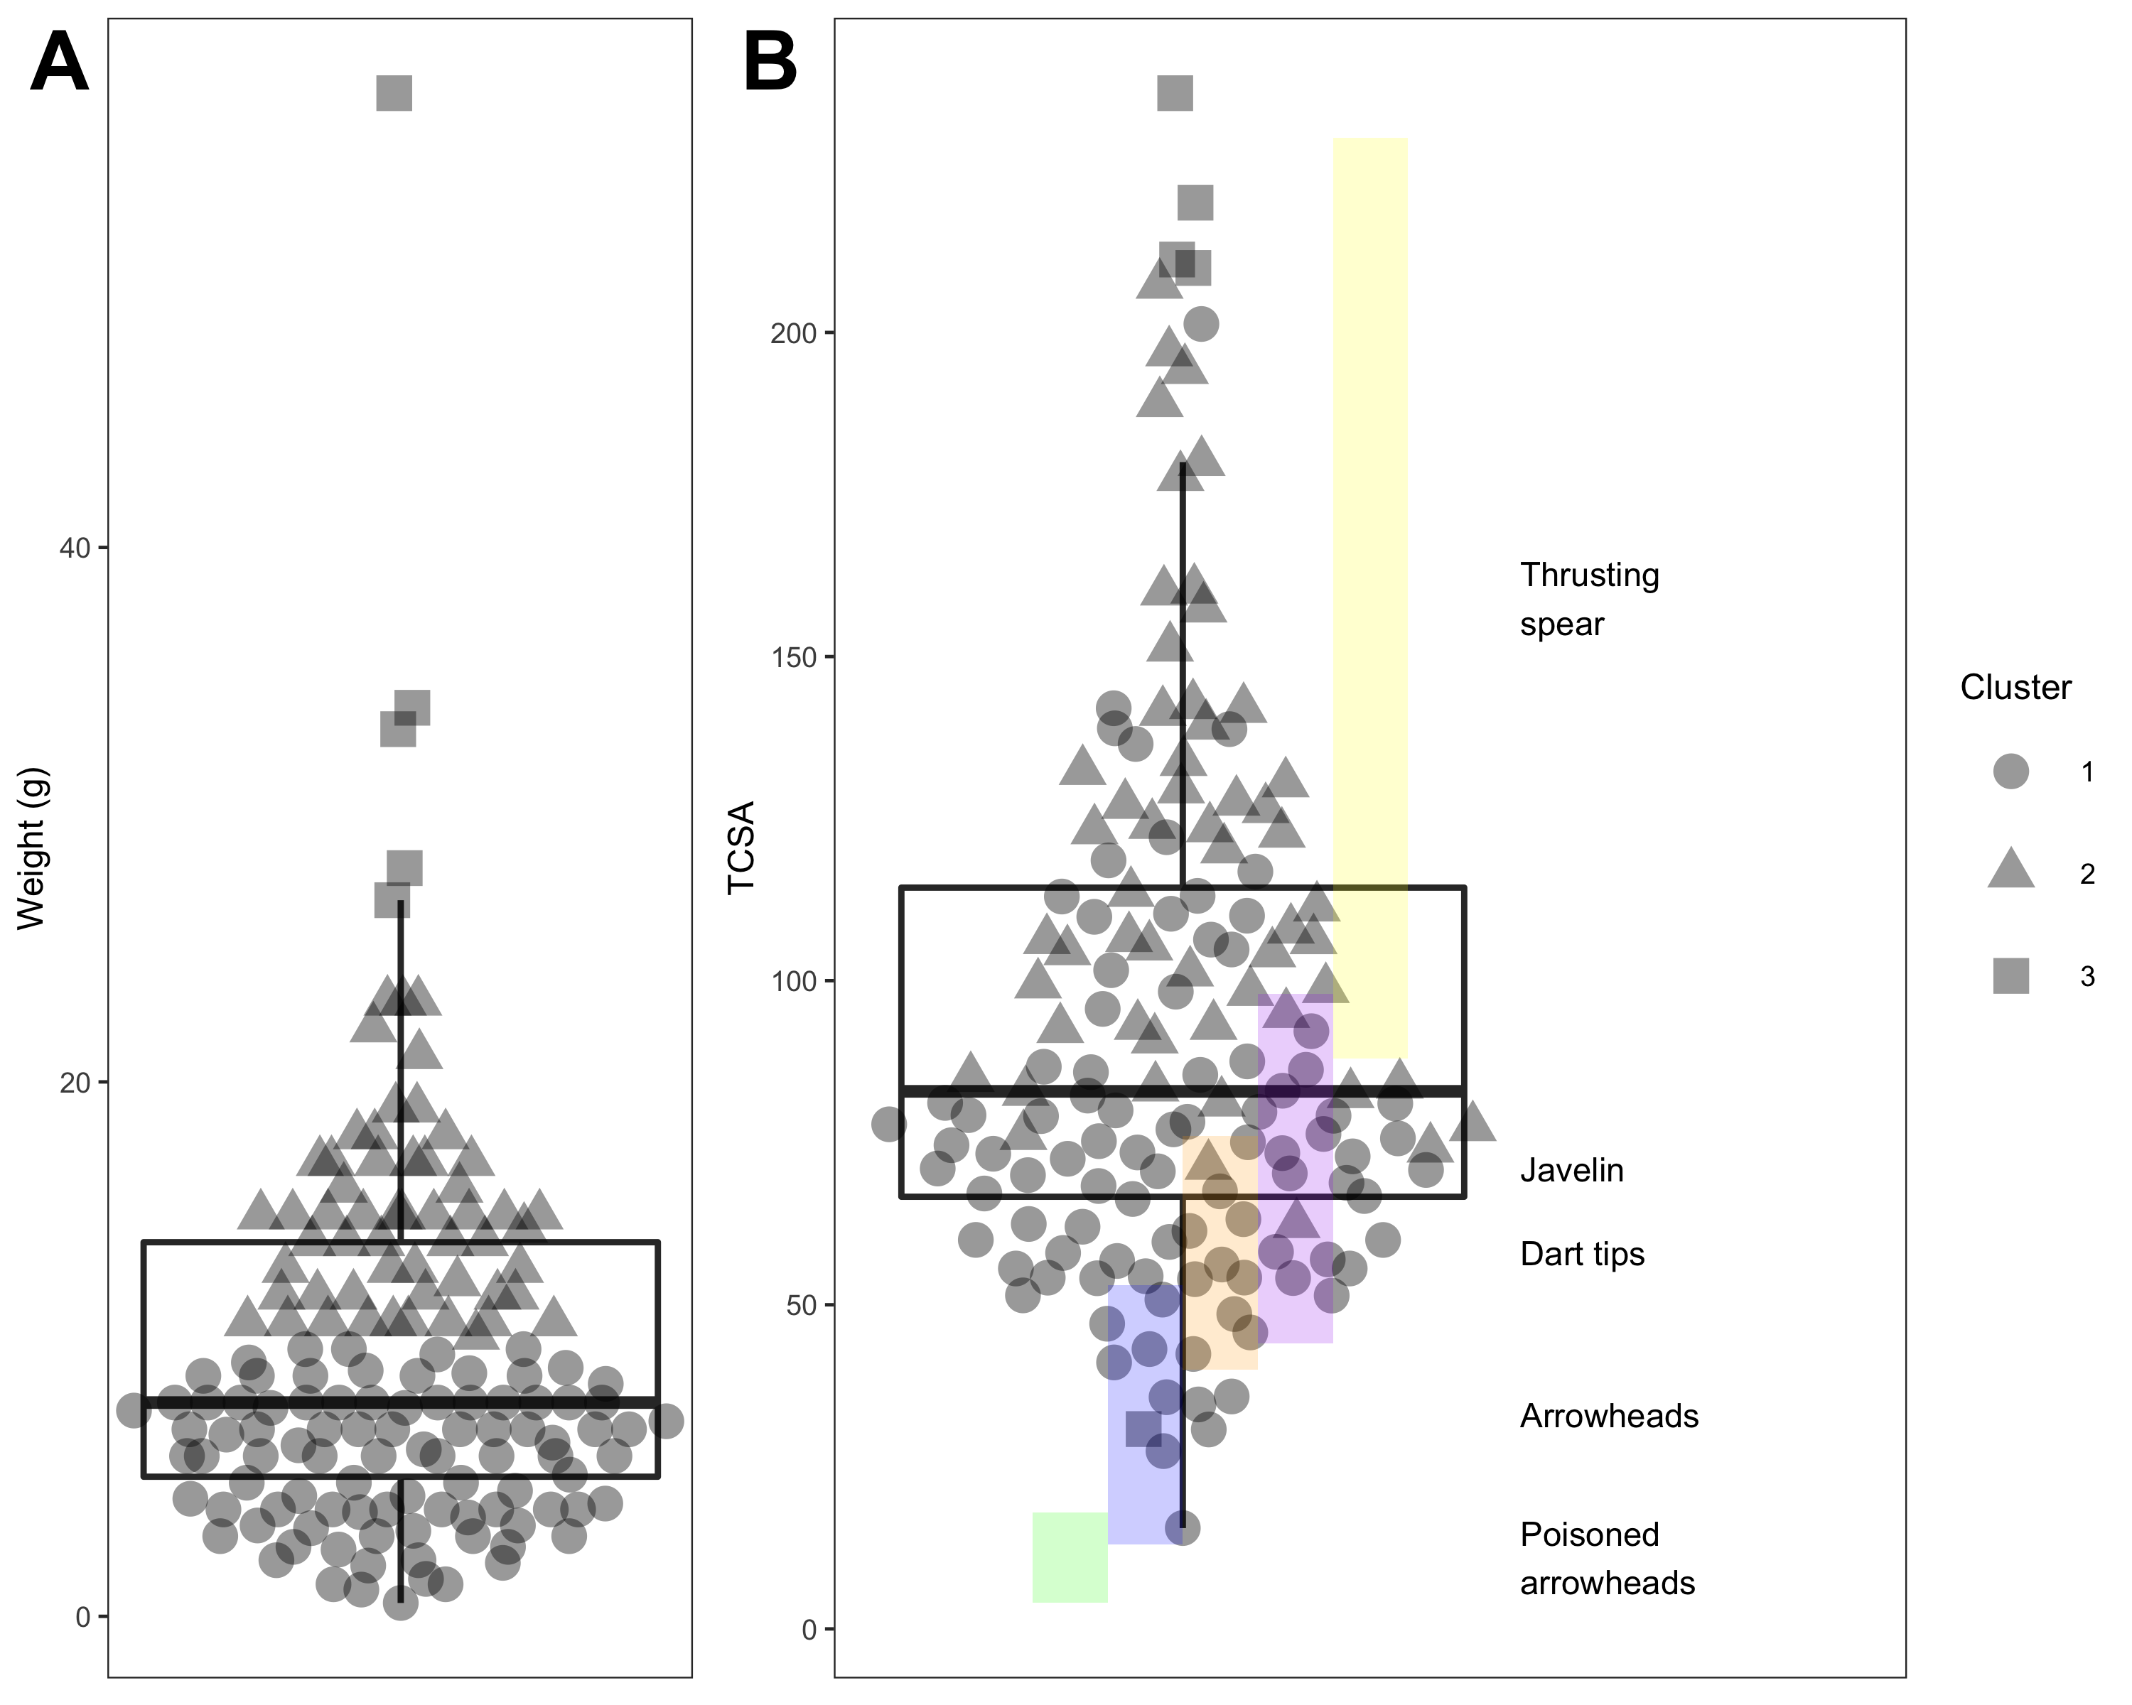

1. Univariate cluster analysis of artefacts by weight reveals three groups or clusters
2. Cluster 1, the smallest (lightest) artifacts, is the lower TCSA, compared Cluster 2. TCSA of Cluster 3 is the highest, except for one artifact, which is lower than 50.
3. We can assumed that artifacts in different clusters might be made for different purposes.

## Adding Radiocarbon dates info to the SP variation (Temoporal pattern)

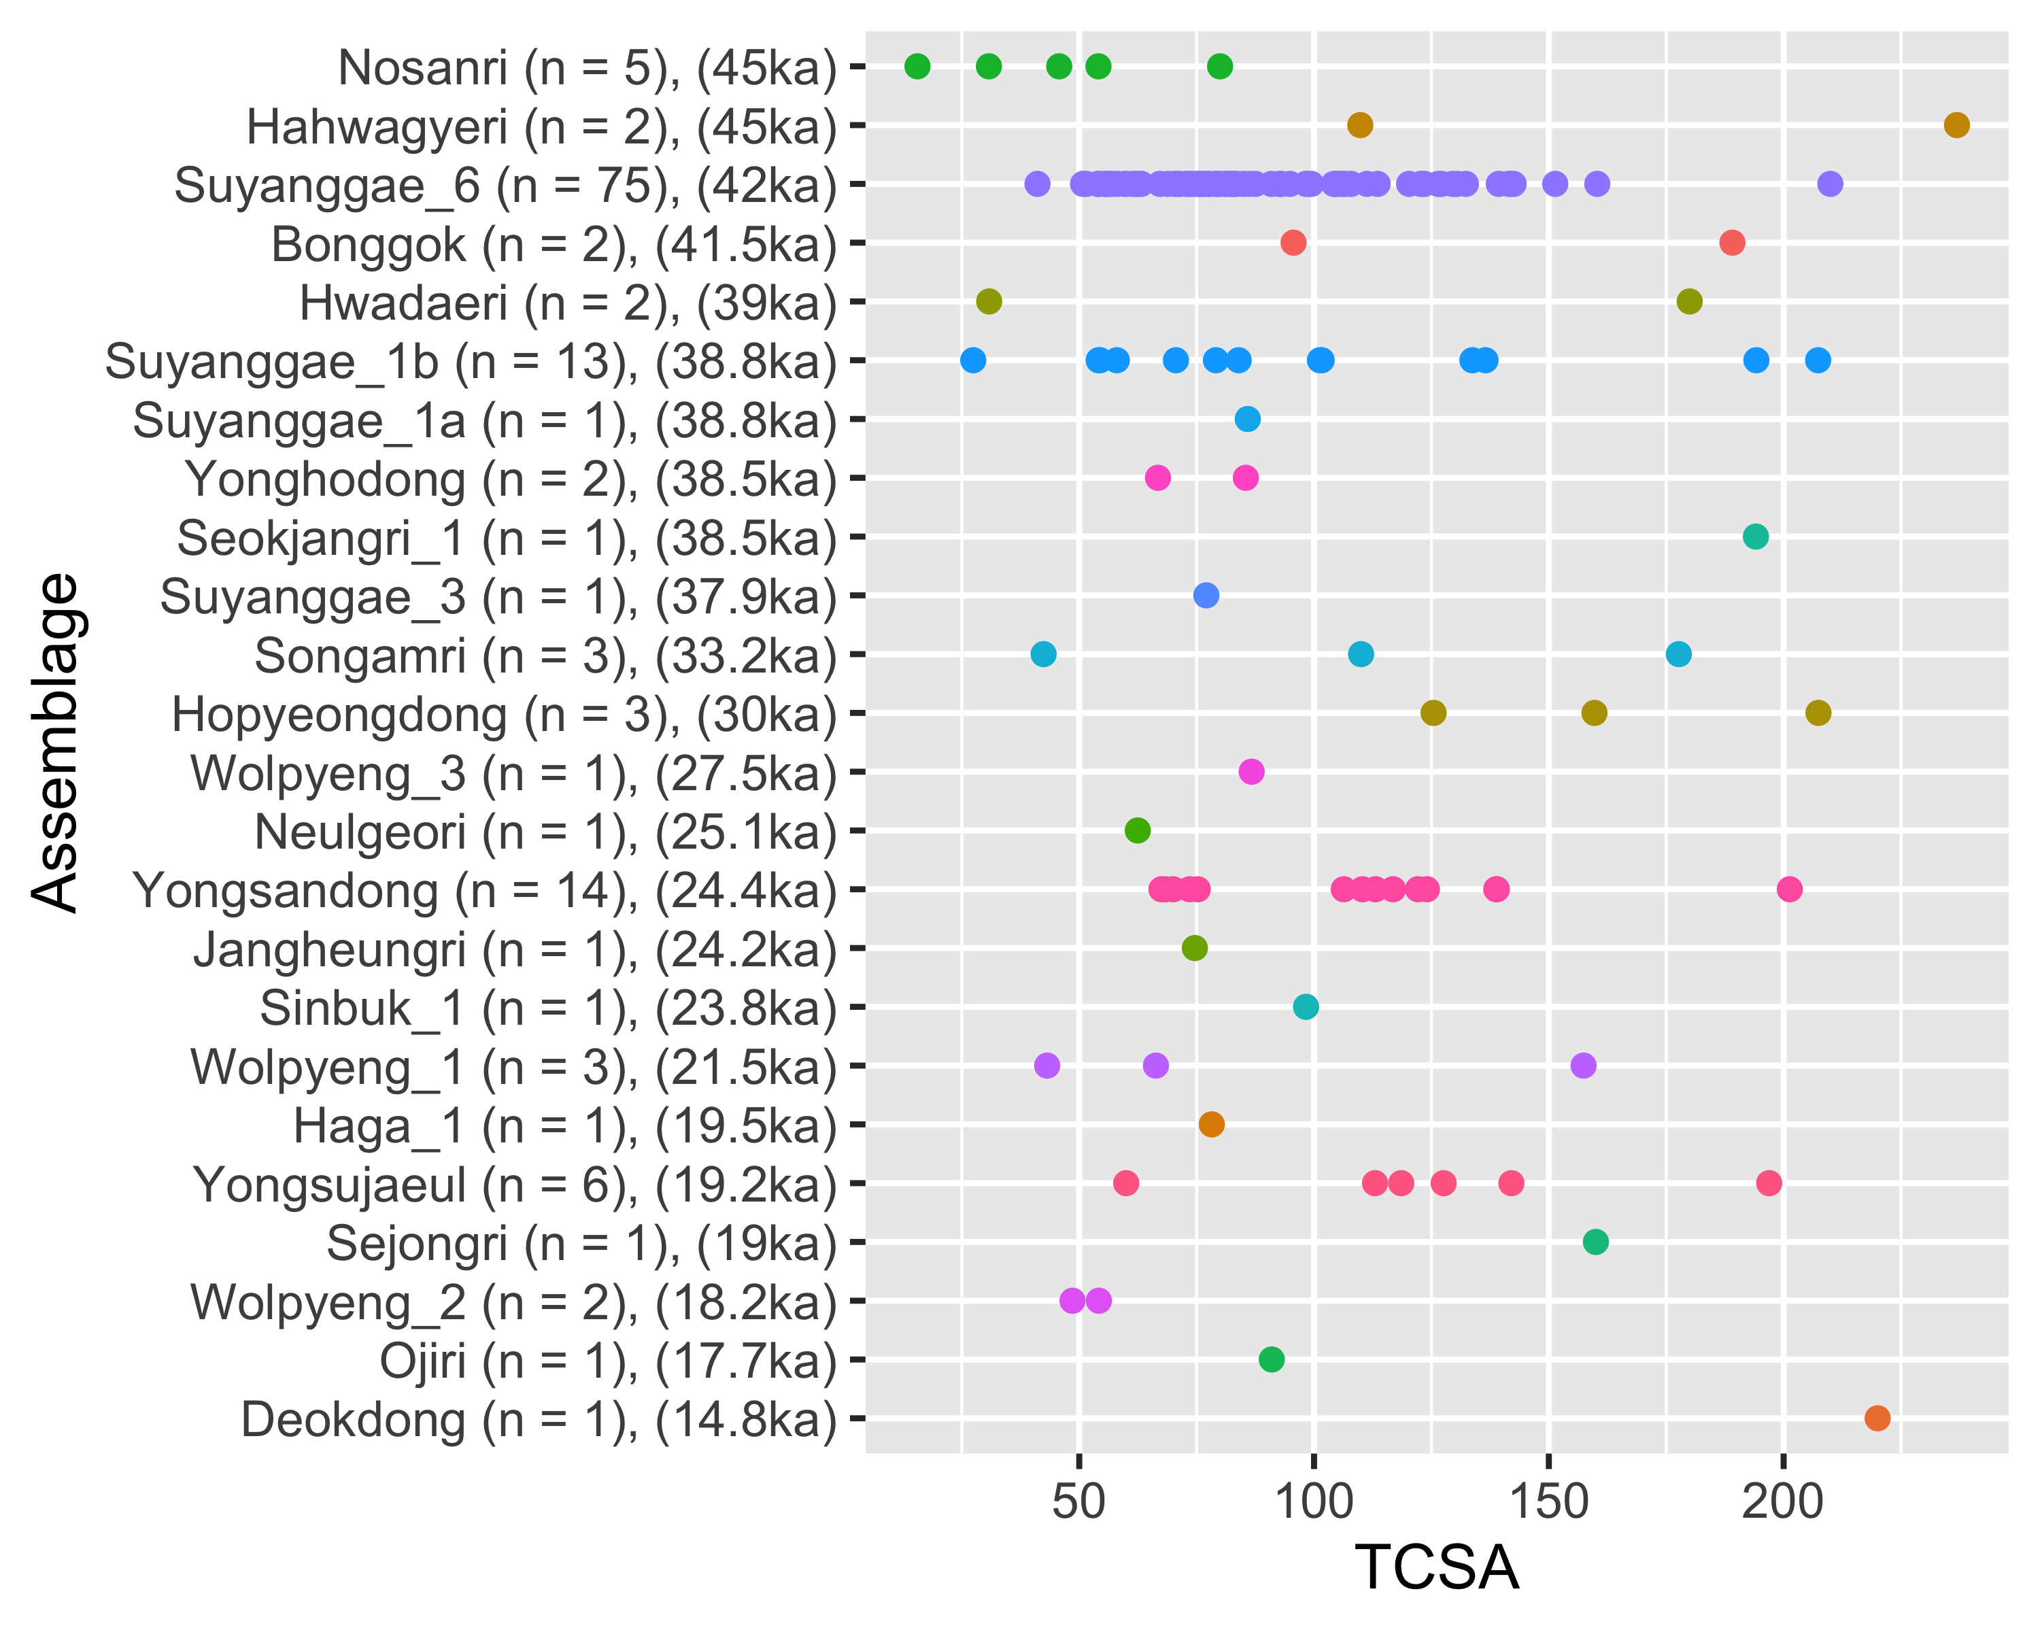

# Discussion

# Conclusion

# Acknowledgements

# CRediT authorship contribution statement

Gayoung Park: Software, Validation, Formal analysis, Resources, Data curation, Writing - original draft, Writing - Review & Editing, Visualization, Project administration.

Marlize Lombard: Conceptualization, Methodology, Writing - Review & Editing, Supervision

Ben Marwick: Software, Validation, Formal analysis, Investigation, Writing - Review & Editing, Visualization, Supervision

Donghee Chong: Data curation, Review & Editing

# References

Angelbeck, B., Cameron, I., 2014. The faustian bargain of technological change: Evaluating the socioeconomic effects of the bow and arrow transition in the coast salish past. Journal of Anthropological Archaeology 36, 93–109.

Bae, C.J., 2017. Late pleistocene human evolution in eastern asia: Behavioral perspectives. Current Anthropology 58, S514–S526.

Bae, C.J., Douka, K., Petraglia, M.D., 2017. On the origin of modern humans: Asian perspectives. Science 358, eaai9067.

Bae, K., 2010. Origin and patterns of the upper paleolithic industries in the korean peninsula and movement of modern humans in east asia. Quaternary International 211, 103–112.

Bettinger, R.L., 2013. Effects of the bow on social organization in western north america. Evolutionary Anthropology: Issues, News, and Reviews 22, 118–123.

Chang, Y., 2013. Human activity and lithic technology between korea and japan from MIS 3 to MIS 2 in the late paleolithic period. Quaternary International 308, 13–26.

Chang, Y., 2002. The study on pointed stone tools in korea. Journal of Korean Paleolithic Society 37–46.

Chong, D., 2021. Tanged point morphology and behavioral diversity of the upper paleolithic assemblages in korea (Master’s Thesis). Department of History, Kyung Hee University, Seoul (in Korea).

Core, R., 2021. Team. R: A language and environment for statistical computing, 2015.

Eren, M.I., Bebber, M.R., Knell, E.J., Story, B., Buchanan, B., 2022. Plains paleoindian projectile point penetration potential. Journal of Anthropological Research 78, 84–112.

Fenenga, F., 1953. The weights of chipped stone points: A clue to their functions. Southwestern Journal of Anthropology 9, 309–323.

Hughes, S.S., 1998. Getting to the point: Evolutionary change in prehistoric weaponry. Journal of Archaeological Method and Theory 5, 345–408.

Kim, E., n.d. Morphological diversity and functional differentiation of tanged-points: Focused on suyanggae, jingeuneul and yongsandong site. Journal of Korean Paleolithic Society.

Kim, E., 2017. Morphological diversity and functional differentiation of tanged-point: Focused on suyanggae, jingeuneul and yongsandong site. Journal of Korean Paleolithic Society 29–47.

Kim, H.-I., 2004. Yongsan-dong paleolithic site, daejeon. Hanguk Guseoki Hakbo 10, 83–94.

Kim, J.C., Chang, Y., 2021. Evidence of human movements and exchange seen from curated obsidian artifacts on the korean peninsula. Journal of Archaeological Science: Reports 39, 103184.

Lee, G., 2015. The characteristics of upper paleolithic industries in korea. Emergence and diversity of modern human behavior in Paleolithic Asia 270–286.

Lee, G., 2012. Characteristics of paleolithic industries in southwestern korea during MIS 3 and MIS 2. Quaternary International 248, 12–21.

Lee, G.-K., Sano, K., 2019. Were tanged points mechanically delivered armatures? Functional and morphometric analyses of tanged points from an upper paleolithic site at jingeuneul, korea. Archaeological and Anthropological Sciences 11, 2453–2465.

Lee, H.-J., Jang, D., 2011b. A study on the function and restoration of tanged tools in the upper palaeolithic of korea. Journal of the Korean Palaeolithic Society 23, 103–120.

Lee, H.-J., Jang, D., 2011a. A study on the function and restoration of tanged tools in the upper palaeolithic of korea. Journal of the Korean Palaeolithic Society 23, 103–120.

Lee, H.W., Bae, C.J., Lee, C., 2017. The korean early late paleolithic revisited: A view from galsanri. Archaeological and Anthropological Sciences 9, 843–863.

Lee, Y., 1985. Excavation report on suyang-gae site in dang-yang county. Extended excavation reports of submerged area by construction of the chung-ju dam. Chungbuk National University Museum, Cheongju.

Lee, Y., Kong, S., 2002b. New analysis results of suyanggae tanged tools in korea. J Korean Paleol Society 6, 13–24.

Lee, Y., Kong, S., 2002a. New analysis results of suyanggae tanged tools in korea. J Korean Paleol Society 6, 13–24.

Lee, Y., Woo, J., Lee, S., An, J., Yun, B., Park, J., Otani, K., Kim, M., Kim, E., Han, S., Jang, H., Choi, D., 2018. Report on the excavation of suyanggae site(loc. I and VI), danyang. Institute of Korean Prehistory.

Lombard, M., 2021. Variation in hunting weaponry for more than 300,000 years: A tip cross-sectional area study of middle stone age points from southern africa. Quaternary Science Reviews 264, 107021.

Lombard, M., 2020. The tip cross-sectional areas of poisoned bone arrowheads from southern africa. Journal of Archaeological Science: Reports 33, 102477.

Lombard, M., Lotter, M.G., Caruana, M.V., 2022. The tip cross-sectional area (TCSA) method strengthened and constrained with ethno-historical material from sub-saharan africa.

Lombard, M., Shea, J.J., 2021. Did pleistocene africans use the spearthrower-and-dart? Evolutionary Anthropology: Issues, News, and Reviews 30, 307–315.

Marwick, B., 2017. Computational reproducibility in archaeological research: Basic principles and a case study of their implementation. Journal of Archaeological Method and Theory 24, 424–450.

Nakazawa, Y., Bae, C.J., 2018. Quaternary paleoenvironmental variation and its impact on initial human dispersals into the japanese archipelago. Palaeogeography, palaeoclimatology, palaeoecology 512, 145–155.

Norton, C.J., Jin, J.J., 2009. The evolution of modern human behavior in east asia: Current perspectives. Evolutionary Anthropology: Issues, News, and Reviews: Issues, News, and Reviews 18, 247–260.

O’Driscoll, C.A., Thompson, J.C., 2018. The origins and early elaboration of projectile technology. Evolutionary Anthropology: Issues, News, and Reviews 27, 30–45.

Park, G., 2013. A study on the stemmed points of the late paleolithic in the korean peninsula. Yeongnam Archaeological Review 64, 39–69.

Park, G., Marwick, B., 2022. How did the introduction of stemmed points affect mobility and site occupation during the late pleistocene in korea? Quaternary Science Reviews 277, 107312.

Pratt, J., Goebel, T., Graf, K., Izuho, M., 2020. A circum-pacific perspective on the origin of stemmed points in north america. PaleoAmerica 6, 64–108.

Rorabaugh, A.N., Fulkerson, T.J., 2015. Timing of the introduction of arrow technologies in the salish sea, northwest north america. Lithic Technology 40, 21–39.

Sahle, Y., Brooks, A.S., 2019. Assessment of complex projectiles in the early late pleistocene at aduma, ethiopia. Plos one 14, e0216716.

Sano, K., Oba, M., 2015. Backed point experiments for identifying mechanically-delivered armatures. Journal of archaeological science 63, 13–23.

Seong, C., 2015. Diversity of lithic assemblages and evolution of late palaeolithic culture in korea. Asian Perspectives 91–112.

Seong, C., 2009. Emergence of a blade industry and evolution of late paleolithic technology in the republic of korea. Journal of Anthropological Research 65, 417–451.

Seong, C., 2008. Tanged points, microblades and late palaeolithic hunting in korea. Antiquity 82, 871–883.

Seong, C., 2004. Quartzite and vein quartz as lithic raw materials reconsidered: A view from the korean paleolithic. Asian Perspectives 73–91.

Seong, C., 2003. Late palaeolithic raw materials in korea: A preliminary analysis. Journal of Korean Ancient Historical Society 1–18.

Seong, C., Bae, C.J., 2016. The eastern asian ‘middle palaeolithic’revisited: A view from korea. Antiquity 90, 1151–1165.

Shea, J.J., 2009. The impact of projectile weaponry on late pleistocene hominin evolution, in: The Evolution of Hominin Diets. Springer, pp. 189–199.

Shea, J.J., 2006. The origins of lithic projectile point technology: Evidence from africa, the levant, and europe. Journal of Archaeological Science 33, 823–846.

Sisk, M.L., Shea, J.J., 2011. The african origin of complex projectile technology: An analysis using tip cross-sectional area and perimeter. International Journal of Evolutionary Biology 2011.

Sitton, J., Story, B., Buchanan, B., Eren, M.I., 2020. Tip cross-sectional geometry predicts the penetration depth of stone-tipped projectiles. Scientific Reports 10, 1–9.

Sohn, P., 1967. Seokjang-ri paleolithic culture. Yeoksahakbo 379–397.

Thomas, D.H., 1978. Arrowheads and atlatl darts: How the stones got the shaft. American antiquity 43, 461–472.

Wadley, L., Mohapi, M., 2008. A segment is not a monolith: Evidence from the howiesons poort of sibudu, south africa. Journal of Archaeological Science 35, 2594–2605.

### Colophon

This report was generated on 2022-10-03 11:22:45 using the following computational environment and dependencies:

─ Session info ───────────────────────────────────────────────────────────────  
 setting value  
 version R version 4.2.1 (2022-06-23)  
 os macOS Big Sur ... 10.16  
 system x86_64, darwin17.0  
 ui X11  
 language (EN)  
 collate en_US.UTF-8  
 ctype en_US.UTF-8  
 tz America/Los_Angeles  
 date 2022-10-03  
 pandoc 2.18 @ /Applications/RStudio.app/Contents/MacOS/quarto/bin/tools/ (via rmarkdown)  
  
─ Packages ───────────────────────────────────────────────────────────────────  
 package * version date (UTC) lib source  
 assertthat 0.2.1 2019-03-21 [1] CRAN (R 4.2.0)  
 backports 1.4.1 2021-12-13 [1] CRAN (R 4.2.0)  
 beeswarm 0.4.0 2021-06-01 [1] CRAN (R 4.2.0)  
 bitops 1.0-7 2021-04-24 [1] CRAN (R 4.2.0)  
 broom 1.0.0 2022-07-01 [1] CRAN (R 4.2.0)  
 cachem 1.0.6 2021-08-19 [1] CRAN (R 4.2.0)  
 callr 3.7.1 2022-07-13 [1] CRAN (R 4.2.0)  
 cellranger 1.1.0 2016-07-27 [1] CRAN (R 4.2.0)  
 Ckmeans.1d.dp * 4.3.4 2022-01-31 [1] CRAN (R 4.2.0)  
 cli 3.4.1 2022-09-23 [1] CRAN (R 4.2.0)  
 codetools 0.2-18 2020-11-04 [1] CRAN (R 4.2.1)  
 colorspace 2.0-3 2022-02-21 [1] CRAN (R 4.2.0)  
 cowplot * 1.1.1 2020-12-30 [1] CRAN (R 4.2.0)  
 crayon 1.5.1 2022-03-26 [1] CRAN (R 4.2.0)  
 curl 4.3.2 2021-06-23 [1] CRAN (R 4.2.0)  
 DBI 1.1.3 2022-06-18 [1] CRAN (R 4.2.0)  
 dbplyr 2.2.1 2022-06-27 [1] CRAN (R 4.2.0)  
 devtools 2.4.4 2022-07-20 [1] CRAN (R 4.2.0)  
 digest 0.6.29 2021-12-01 [1] CRAN (R 4.2.0)  
 dplyr * 1.0.9 2022-04-28 [1] CRAN (R 4.2.0)  
 ellipsis 0.3.2 2021-04-29 [1] CRAN (R 4.2.0)  
 evaluate 0.16 2022-08-09 [1] CRAN (R 4.2.1)  
 fansi 1.0.3 2022-03-24 [1] CRAN (R 4.2.0)  
 farver 2.1.1 2022-07-06 [1] CRAN (R 4.2.0)  
 fastmap 1.1.0 2021-01-25 [1] CRAN (R 4.2.0)  
 forcats * 0.5.1 2021-01-27 [1] CRAN (R 4.2.0)  
 foreign 0.8-82 2022-01-16 [1] CRAN (R 4.2.1)  
 fs 1.5.2 2021-12-08 [1] CRAN (R 4.2.0)  
 gargle 1.2.0 2021-07-02 [1] CRAN (R 4.2.0)  
 generics 0.1.3 2022-07-05 [1] CRAN (R 4.2.0)  
 ggbeeswarm * 0.6.0 2017-08-07 [1] CRAN (R 4.2.0)  
 ggmap * 3.0.0 2019-02-05 [1] CRAN (R 4.2.0)  
 ggplot2 * 3.3.6 2022-05-03 [1] CRAN (R 4.2.0)  
 ggrepel * 0.9.1 2021-01-15 [1] CRAN (R 4.2.0)  
 glue 1.6.2 2022-02-24 [1] CRAN (R 4.2.0)  
 googledrive 2.0.0 2021-07-08 [1] CRAN (R 4.2.0)  
 googlesheets4 1.0.0 2021-07-21 [1] CRAN (R 4.2.0)  
 gtable 0.3.1 2022-09-01 [1] CRAN (R 4.2.0)  
 haven 2.5.0 2022-04-15 [1] CRAN (R 4.2.0)  
 here * 1.0.1 2020-12-13 [1] CRAN (R 4.2.0)  
 hms 1.1.1 2021-09-26 [1] CRAN (R 4.2.0)  
 htmltools 0.5.3 2022-07-18 [1] CRAN (R 4.2.0)  
 htmlwidgets 1.5.4 2021-09-08 [1] CRAN (R 4.2.0)  
 httpuv 1.6.5 2022-01-05 [1] CRAN (R 4.2.0)  
 httr 1.4.3 2022-05-04 [1] CRAN (R 4.2.0)  
 jpeg 0.1-9 2021-07-24 [1] CRAN (R 4.2.0)  
 jsonlite 1.8.0 2022-02-22 [1] CRAN (R 4.2.0)  
 knitr 1.39 2022-04-26 [1] CRAN (R 4.2.0)  
 labeling 0.4.2 2020-10-20 [1] CRAN (R 4.2.0)  
 later 1.3.0 2021-08-18 [1] CRAN (R 4.2.0)  
 lattice 0.20-45 2021-09-22 [1] CRAN (R 4.2.1)  
 legendMap * 1.0 2022-10-03 [1] Github (3wen/legendMap@707f00c)  
 lifecycle 1.0.2 2022-09-09 [1] CRAN (R 4.2.0)  
 lubridate 1.8.0 2021-10-07 [1] CRAN (R 4.2.0)  
 magrittr * 2.0.3 2022-03-30 [1] CRAN (R 4.2.0)  
 maps * 3.4.0 2021-09-25 [1] CRAN (R 4.2.0)  
 maptools * 1.1-4 2022-04-17 [1] CRAN (R 4.2.0)  
 Matrix 1.4-1 2022-03-23 [1] CRAN (R 4.2.1)  
 memoise 2.0.1 2021-11-26 [1] CRAN (R 4.2.0)  
 mgcv 1.8-40 2022-03-29 [1] CRAN (R 4.2.1)  
 mime 0.12 2021-09-28 [1] CRAN (R 4.2.0)  
 miniUI 0.1.1.1 2018-05-18 [1] CRAN (R 4.2.0)  
 modelr 0.1.8 2020-05-19 [1] CRAN (R 4.2.0)  
 munsell 0.5.0 2018-06-12 [1] CRAN (R 4.2.0)  
 nlme 3.1-158 2022-06-15 [1] CRAN (R 4.2.0)  
 pillar 1.8.1 2022-08-19 [1] CRAN (R 4.2.0)  
 pkgbuild 1.3.1 2021-12-20 [1] CRAN (R 4.2.0)  
 pkgconfig 2.0.3 2019-09-22 [1] CRAN (R 4.2.0)  
 pkgload 1.3.0 2022-06-27 [1] CRAN (R 4.2.0)  
 plyr 1.8.7 2022-03-24 [1] CRAN (R 4.2.0)  
 png 0.1-7 2013-12-03 [1] CRAN (R 4.2.0)  
 prettyunits 1.1.1 2020-01-24 [1] CRAN (R 4.2.0)  
 processx 3.7.0 2022-07-07 [1] CRAN (R 4.2.0)  
 profvis 0.3.7 2020-11-02 [1] CRAN (R 4.2.0)  
 promises 1.2.0.1 2021-02-11 [1] CRAN (R 4.2.0)  
 ps 1.7.1 2022-06-18 [1] CRAN (R 4.2.0)  
 purrr * 0.3.4 2020-04-17 [1] CRAN (R 4.2.0)  
 R6 2.5.1 2021-08-19 [1] CRAN (R 4.2.0)  
 raster * 3.5-29 2022-08-14 [1] CRAN (R 4.2.0)  
 rbibutils 2.2.9 2022-08-15 [1] CRAN (R 4.2.0)  
 Rcpp 1.0.9 2022-07-08 [1] CRAN (R 4.2.0)  
 Rdpack 2.4 2022-07-20 [1] CRAN (R 4.2.0)  
 readr * 2.1.2 2022-01-30 [1] CRAN (R 4.2.0)  
 readxl * 1.4.1 2022-08-17 [1] CRAN (R 4.2.0)  
 remotes 2.4.2 2021-11-30 [1] CRAN (R 4.2.0)  
 reprex 2.0.1 2021-08-05 [1] CRAN (R 4.2.0)  
 rgeos 0.5-9 2021-12-15 [1] CRAN (R 4.2.0)  
 RgoogleMaps 1.4.5.3 2020-02-12 [1] CRAN (R 4.2.0)  
 rjson 0.2.21 2022-01-09 [1] CRAN (R 4.2.0)  
 rlang 1.0.6 2022-09-24 [1] CRAN (R 4.2.0)  
 rmarkdown 2.14 2022-04-25 [1] CRAN (R 4.2.0)  
 rprojroot 2.0.3 2022-04-02 [1] CRAN (R 4.2.0)  
 rstudioapi 0.13 2020-11-12 [1] CRAN (R 4.2.0)  
 rvest 1.0.2 2021-10-16 [1] CRAN (R 4.2.0)  
 scales 1.2.1 2022-08-20 [1] CRAN (R 4.2.0)  
 sessioninfo 1.2.2 2021-12-06 [1] CRAN (R 4.2.0)  
 shiny 1.7.2 2022-07-19 [1] CRAN (R 4.2.0)  
 sp * 1.5-0 2022-06-05 [1] CRAN (R 4.2.0)  
 stringi 1.7.8 2022-07-11 [1] CRAN (R 4.2.0)  
 stringr * 1.4.0 2019-02-10 [1] CRAN (R 4.2.0)  
 terra 1.6-7 2022-08-07 [1] CRAN (R 4.2.0)  
 tibble * 3.1.8 2022-07-22 [1] CRAN (R 4.2.0)  
 tidyr * 1.2.0 2022-02-01 [1] CRAN (R 4.2.0)  
 tidyselect 1.1.2 2022-02-21 [1] CRAN (R 4.2.0)  
 tidyverse * 1.3.2 2022-07-18 [1] CRAN (R 4.2.0)  
 tzdb 0.3.0 2022-03-28 [1] CRAN (R 4.2.0)  
 urlchecker 1.0.1 2021-11-30 [1] CRAN (R 4.2.0)  
 usethis 2.1.6 2022-05-25 [1] CRAN (R 4.2.0)  
 utf8 1.2.2 2021-07-24 [1] CRAN (R 4.2.0)  
 vctrs 0.4.2 2022-09-29 [1] CRAN (R 4.2.0)  
 vipor 0.4.5 2017-03-22 [1] CRAN (R 4.2.0)  
 viridisLite 0.4.1 2022-08-22 [1] CRAN (R 4.2.0)  
 withr 2.5.0 2022-03-03 [1] CRAN (R 4.2.0)  
 xfun 0.32 2022-08-10 [1] CRAN (R 4.2.1)  
 xml2 1.3.3 2021-11-30 [1] CRAN (R 4.2.0)  
 xtable 1.8-4 2019-04-21 [1] CRAN (R 4.2.0)  
 yaml 2.3.5 2022-02-21 [1] CRAN (R 4.2.0)  
  
 [1] /Library/Frameworks/R.framework/Versions/4.2/Resources/library  
  
──────────────────────────────────────────────────────────────────────────────

The current Git commit details are:

Local: master /Users/gayoungp/Desktop/tcsakoreanpaleolithic  
Remote: master @ origin (https://github.com/parkgayoung/tcsakoreanpaleolithic.git)  
Head: [9beb54a] 2022-10-03: the chunk label needs fig-xxx for captions to work